|  |  |
| --- | --- |
| **Field** | **Property** |
| Gravitational | Mass |
| Electric | Charge |
| Magnetic | Moving Charge (accelerating?) |

The relative no. of field lines (/density of lines) allow you to differentiate between a small positive charge and a large mass for example

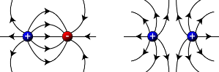**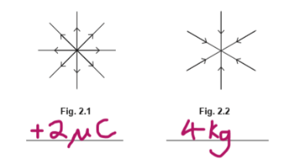Field of force**: region/volume of space in which bodies with a particular property experience a force.

**Field lines**: visual representation of field, field direction = tangent to field line, Field lines can’t cross as this would imply omnidirection but a field is unidirectional at a given point, closer lines = stronger field,parrallel&equally spaced = uniform field, Lines converge/diverge = radial non-uniform field, field strength = vector

**Newton’sLaw of Universal Gravitation**: $F=G\frac{mM}{r^{2}}$, Every body in the universe attracts every other body. Between two point masses the gravitational force of attraction is directly propotional to the product of the masses and inversely proportional to the square of their separation

**Gravitational Field Strength**: Force per unit mass. **Gravitational field:** region where an object with mass experiences a force.

F has infinite range, field lines are radially inwards, field lines hit surface at right angles, as the radius is large, the lines can be considered uniform, not concerned with how g varies below earths surface.

At the neutral point between two bodies, the field strength due to each is equal so total is zero, more difficult to travel from more massive body to less massive as more work needs to be done against a larger gravitational force for a longer distance (pulled to destination after passing neutral point).

|  |  |
| --- | --- |
| **Geostationary** | |
| T | 24 hrs (geosynchronous) (note: same $ω$) |
| Height | 3.59 × 10^7 m |
| Radius | 4.23 × 10^7 m |
| Direction | Same as Earth’s rotation |
| Energy | Don’t require energy as Ek and Ep are constant |
| Use | Communication, meteorology etc |
| Position | Above equator |

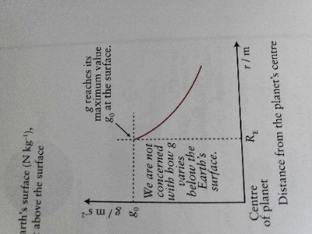**Kepler’s Third Law**: The square of the period of revolution of the planets about the Sun is directly proportional to the cube of their mean distances from it. $\frac{T^{2}}{r^{3}}$ = const.

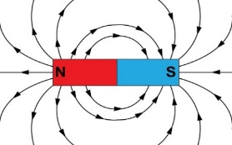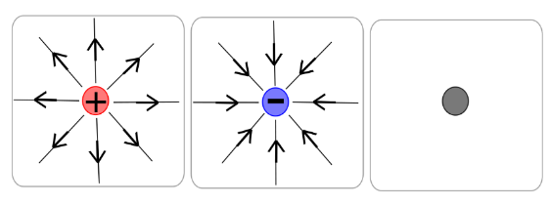To link Kepler & Newton laws use: $F_{c}=F_{g} = mrω^{2}= G\frac{mM}{r^{2}} = mr{\left(\frac{2π}{T}\right)}^{2}$

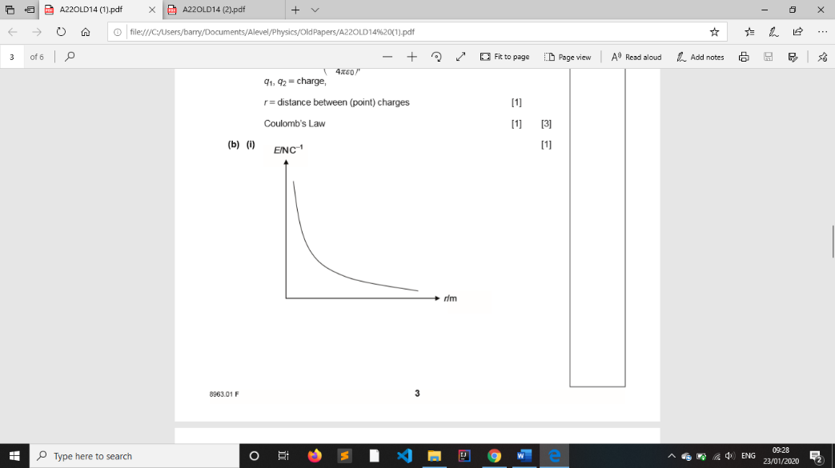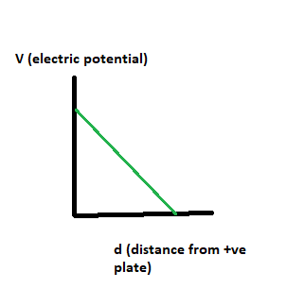**Electric field strength**, $E = \frac{F}{q}$, **Force per unit charge**

Vector **direction** of field strength is that of the force on the + charge.

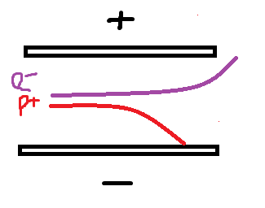**Coulomb’s Law**: Between every two, point charges there exists an electrical force that is directly proportional to the product of the charges and is inversely proportional to the square of their separation

$F = \frac{kq_{1}q_{2}}{r^{2}} = \frac{q_{1}q_{2}}{{4πε_{0}r}^{2}}$, where $ε_{0}$ is the permittivity of free space (vacuum)

At neutral point between two charges the field strength as a result of each charge is equal. Field towards negative and away from positive by convention

Same E at all points on a charged sphere. Electric field strength within charged plates is uniform, however, electrical potential decreases as the distance from the positive plate increases. $E = -\frac{V}{d} = - potential gradient$

|  |  |  |
| --- | --- | --- |
|  | Gravitational | Electric |
| Differences | * Acts on mass, Always attractive (lines radially inwards), Can’t shield from it | * Acts on charges, Attractive or repulsive (lines radially inwards or radially outwards), Shielding is possible |
| Similarities | Both follow inverse square rule where field strength decreases from point as $\frac{1}{r^{2}}$ (and spacing between lines increases), Infinite range, Both radial | |

If a charged sphere is placed beside another charged sphere on a string, then the horizontal component of tension in the string is equal to the magnitude of the repulsive force between the spheres

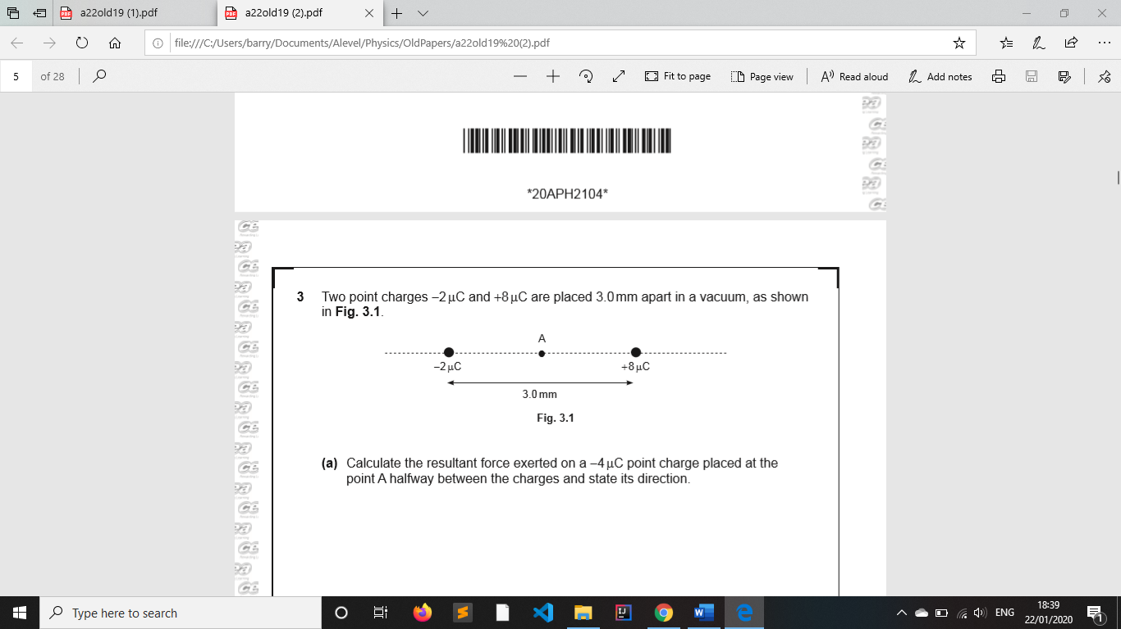The neutral point for this system is located to the left of the -2µC charge as the forces must be opposing directions. This also increases the distance from 8µC charge, decreasing, it’s magnitude. This allows for a balance of direction and magnitude, leading to a resultant force, at that point, of zero.

If a -4µC charge is placed at A then the resultant force on it will be $\frac{KQ_{8}Q_{4}}{{(1.5mm)}^{2}}+ \frac{KQ_{2}Q_{4}}{{(1.5mm)}^{2}}$

For an electron accelerated through a potential difference (not the same as the voltage of the plates): $eV = \frac{1}{2}mv^{2}$

May need to equate electrostatic force with either weight or centripetal force for some questions